Scout

User’s Guide

1. Introduction

Scout is intended to be run before a weekly CCHR meeting. It produces the weekly report showing what has happened during the preceding week to the bills which are of interest to us.

There is work behind the scene of that weekly report – work selecting (with some help from Scout) the bills to review, reviewing those bills, deciding whether we are interested and how interested we are, and writing up a report on the bill.

The report written on each bill has evolved over the years into a standardized form. There is room for the creative writer within this form, but there are some elements that are required to be present because Scout uses them in generating the weekly report.

A write-up on AB-1976 from 2020 is appended to this document. A weekly report is also appended.

* 1. Individual Bill Reports
  2. Weekly Report
  3. Weekly News
     1. Highlights
     2. Weekly Report
     3. Weekly Talk

1. Top-Level Window
2. Scout Starting Points

When Scout starts, it displays this window

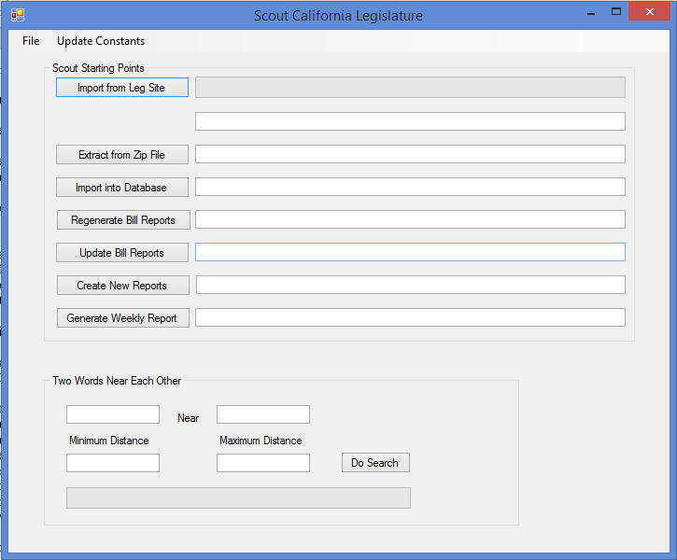

Begin by clicking on the “Import from Leg Site” button. This causes Scout to import the latest bill data from the legislature’s download site. Then Scout proceeds to the “Extract From Zip File” step, followed by “Import into Database” and so on down through “Generate Weekly Report” which, as you might expect generates the weekly report.

A key point in understanding Scout is that it proceeds in a sequence – the one shown above.

You can start Scout at any point in this sequence. If, for example, you have made some edits to one or more individual bill reports, then you can simply click “Generate Weekly Report”. No need to go through the other steps.

You can start at any one of those sequence buttons.

1. Two Words Near Each Other

To Be Written Later – a utility for searching bills for two words within so many words of each other.

1. Importing Data from the Legislature Site
2. Extracting Legislature Data into Files
3. Importing Legislature Data into the Database
4. Regenerating the Bill Reports
5. Updating Bill Reports
6. Creating New Bill Reports
7. Creating the Weekly Report